Name : Sarak Adhik Baba
PRN : 123B2F152
Assignment No. 4

Problem Statement:

Implement normal distribution in python and visualize it for Mean =100, standard _deviation =4, dataset size=100000

Objective:

The goal of this assignment is to understand the normal distribution, its properties, and to simulate it using Python. We will:
- Visualize the distribution using Matplotlib and Seaborn.
- Use Scipy for calculating probabilities and Z-scores.
- Perform normality tests to validate data distribution.

Prerequisites:
1.Python environment with libraries:
- numpy, seaborn, matplotlib, scipy, statsmodels.
- Basic understanding of statistics, especially probability distributions.
- Familiarity with data visualization techniques and normality tests.

Theory:

What is Normal Distribution?

Normal Distribution or Gaussian Distribution-It is a continuous probability distribution that has the bell curve and it means when data is plotted, forms normalized form. It represents real-world quantities:

People's heights or weights.
Marks in an exam.
Employee rankings
In a normal distribution, with the highest density value area is around mean and very farthest values are considered as minimum.

Properties of a Normal Distribution

Symmetry: The curve is symmetric about the mean.
Mean = Median = Mode.
Empirical Rule (68–95–99 Rule):
68% of values lie within 1 standard deviation of the mean.
95% lie within 2 standard deviations.
99.7% lie within 3 standard deviations.
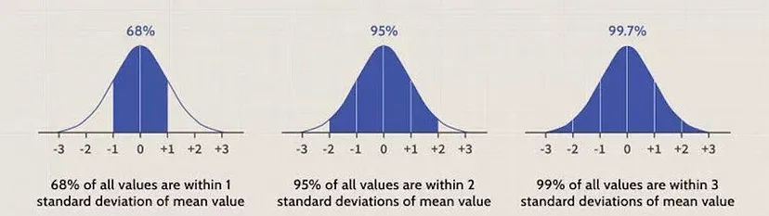

Mean and Standard Deviation:
Mean determines the center of the distribution.
Standard deviation affects the curve’s width (higher = flatter, lower = steeper).
Skewness: Measures asymmetry in the data.
0 skewness implies a perfectly symmetrical normal distribution.
Kurtosis: Measures the "tailedness" of the curve.
Leptokurtic (k > 3): Heavy tails with more outliers.
Platykurtic (k < 3): Light tails, fewer outliers.

Algorithm:
Step 1: Simulating Normal Distribution in Python
Generate data using numpy with a specified mean and standard deviation.

Step 2: Visualization
Plot the distribution using seaborn and overlay KDE (Kernel Density Estimation).

Step 3: Standardize Data (Z-scores)
Convert values to Z-scores to analyze how far they deviate from the mean.

Step 4: Normality Tests
Perform Shapiro-Wilk Test and Kolmogorov-Smirnov Test to validate normality.

References:
- Python Official Documentation
- Numpy Documentation
- Seaborn Documentation
- https://medium.com/@snehabajaj108/the-normal-distribution-with-python-2cb3bf57ee47

- Conclusion:
In this assignment, we learned of the normal distribution (or Gaussian), which is a critical concept in statistics and data analysis. This includes its basic properties such as symmetry around the mean, empirical rule (68–95-99.7), and importance of measures like Mean, standard deviation skewness and kurtosis.

